3D Renderer Guide

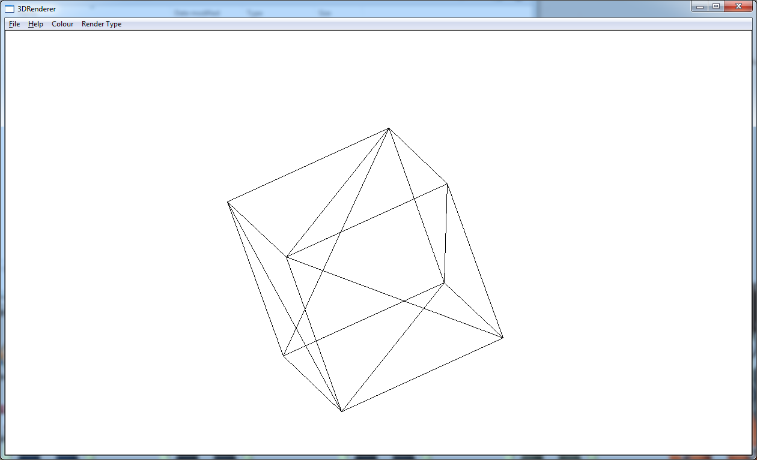
When the appication begins a Cube will be loaded and it will start to spin, to stop it from spining, click on the File menu at the top and click Rotate, this will stop and start the rotation.

The File menu also has a LoadObject button which enables you to load a select few of other objects.

The Colour Menu alows you to change the colour of the Wireframe or Solid colour by bringing up a menu so you can select a colour.

Last but not least the RenderType Menu button alows you to switch between WireFrame and SolidColour.

